UNIT PLAN: Infographics DATE: NA

SUBJECT: Visual arts/Math integration GRADE: 9 DURATION: 3 Lessons

BIG IDEA – Develop new communication skills by learning to share information succinctly using language, graphic design, and images.

Desired Results
Established Goals (PLO’s)
- Identify a variety of imagery sources and analyse and evaluate image development strategies used by self, peers, and others.
- Develop and make images using a combination of image development techniques.
- Demonstrate an understanding of the roles of artists and the visual arts in reflecting, sustaining, and challenging beliefs and traditions in society.

Understandings  Students will understand:  - What are the big ideas?  - What specific understandings about them are desired?  - What misunderstandings are predictable?  - Infographics aren’t better than their data.  - The importance of colour and its meaning in their work.  - How artists can influence societies opinion through their creations. | Essential Questions  What provocative questions will foster inquiry, understanding and transfer of learning?  - Does the infographic cite their sources? and, Are the sources  reputable?  - Is the data relevant? and, how old is the data?  - What is the motive of the organization, person, or group that created the infographic? Is it to educate, entertain, or sell something?  - Is there an angle or bias coming through? Are readers being  manipulated through the text, colors or graphics?  - Does the infographic represent an accurate outline of the data?
Students will know:  - What key knowledge skills will the students acquire as a result of this unit?  - What should they eventually be able to do as a result of such knowledge and skills?  - How to display data accurately using infographics  - How to question the information presented in other infographics | Students will be able to:  - Make their own infographic  - Analyse the image development strategies used in other info graphics including their own and their peers.  - Discuss the important role that artists play in reflecting, sustaining, and challenging societal beliefs and traditions.
Assessment Evidence
Summative:  - Through what authentic performance tasks will students demonstrate the desired understandings?  - By what criteria will performances of understanding be judged?  CHECK TO MAKE SURE IT ALLIGNS | Formative:  - Through what other evidence (e.g. quizzes, tests, academic prompts, observations, homework, journals) will students demonstrate achievement of the desired results?  - What provision will there be for formative assessment?  - How will students reflect upon and self-assess their learning?  CHECK TO MAKE SURE IT ALLIGNS

Learning Plan
Lesson  & Date | IRP Outcomes  PLO | Specific Lesson Outcomes  SLO | Activities  Teaching Strategies | Materials/ Resources | Assessment
Lesson 1  Intro to Infographics | Identify a variety of imagery sources and analyse and evaluate image development strategies used by self, peers, and others.  Develop and make images using a combination of image development techniques.  Demonstrate an understanding of the roles of artists and the visual arts in reflecting, sustaining, and challenging beliefs and traditions in society. | Understand the function of infographics and the artists who make them  Develop an awareness of critical thinking in reference to data | Hook – 5 min – Appendix A  - Teacher stands at the front of the class and spouts off seemingly incomprehensible data using an infographic.  - Ask students to repeat what they learned.  - Show the infographic on the overhead for 1 min.  - Ask students if they learned anything  Think/Pair/Share – 6 min  - What was the difference between the two methods used to convey data?  - Which one worked better for you?  - Why do you think that is?  Class discussion/Mind mapping– 10 min  As the class discusses their previous knowledge of infographics, the teacher creates a mind map on the board to describe their understanding.  - What is an infographic?  - What are its purposes?  - Who can they be made for?  - Why would an artist choose to make an infographic?  - What do you think are the key components to a good infographic?  Intro to Infographics (part1) – 10 min – Appendix B  - Go over powerpoint presentation (part 1) on overhead  - Invite the students to ask questions  Frontloading – Should we always believe infographics? – 5 min  - Show example of misleading graph on overhead.  http://www.venganza.org/images/spreadword/pchart1.pdf  - Ask students to analyze the information presented and answer the handout individually. (This will scaffold the lesson 2 activity – Finding Data accuracy) - Appendix C  Critical thinking brainstorm/gallery walk – 10 min  Ask the students in table groups of 4 or 5 to brainstorm questions that audiences should ask themselves before believing information presented in an infographic.  - Students must write down the questions they brainstormed on the chart paper provided.  - Have a gallery walk to explore the ideas of other table groups.  - Discuss other possible questions.  Intro to Infographics (part 2) – 5 min – Appendix B  - Go over the last half of the powerpoint presentation.  - Invite students to ask questions.  Frontloading – The importance of collaboration – 3 min  - Teacher explains the importance of collaboration in reference to the workforce.  - Scaffold that the students will be put in pairs and the emotional ramifications of putting down your team mate.  Closure – Idea development/team selection – 6 min  - Explain that we are going to make our own infographics in pairs.  - Pair teams will be assigned by the teacher “randomly” (this will seem random from the perspective of the students but will be calculated by the teacher)  - Handout the list of possible topics and let the students know that they can also explore other topics not on the list but need to ask permission before beginning. Appendix D | Hook Infographic  Board/board marker  Intro to Infographics powerpoint presentation – parts 1 & 2  Chart paper x number of table groups (6-7)  Markers x number of table groups (6-7)  Possible topics handouts. | Formative  Think/Pair/Share/ - The purpose of infographics and how they reveal data  Mind mapping discussion  Teacher centered presentation – Into to Infographics  Student analyzed infographic – believability  Critical thinking brainstorm/gallery walk
Lesson 2  Data accuracy | Identify a variety of imagery sources and analyse and evaluate image development strategies used by self, peers, and others.  Develop and make images using a combination of image development techniques.  Demonstrate an understanding of the roles of artists and the visual arts in reflecting, sustaining, and challenging beliefs and traditions in society. | Develop an awareness for data accuracy  Find accurate data for their specific infogrph | NOTE – This class will take place in the computer lab  Hook – ROYGBIV – 1 min  After students are seated, teacher writes ROYGBIV on the board.  Ask students if this means anything to them.  Colour meaning activity – 5 min – Appendix E  - When students enter the class there is a handout paper on each desk.  - Teacher holds up a piece of red paper.  - The students individually write down what that colour represents for them. This can be anything, a mood, a place, a thing, a sport.  - Continue the process with various colours; white, black, blue, grey, brown, yellow, orange, pink, purple, green  - Discuss cultural meaning.  - Table share out  - Invite the students to share anything that surprised them.  Frontloading – 4 min  - Explain that students will need to search for the accuracy of information presented in an infograph.  - Discuss where to look and how to substantiate the data using other media sources.  - Review Lesson 1 Handout – Should we always believe infographs?  - Explain that the teacher will be available to help them in the process.  Finding Data accuracy – 20 min –  - Hand out various infographs to student teams – Appendix F  - Have students search the internet for data accuracy.  - Fill in handout about the sources they searched – Appendix G  Finding their own accurate data – 23 min  - Students will now find accurate data that they will use in their infograph using the internet.  - Students will need to answer the handout showing where they received their data and how they know it is accurate. Appendix H  Closure – Whip – 3 min  - Students will give one sentence of information that describes a piece of data they will use in their infograph. | Board and marker  Coloured paper squares – red, white, black, grey, yellow, blue, pink, green  Colour meaning activity handout x number of students.  Inforgraphs x number of student teams (appox. 15)  Computer lab  Finding data accuracy x student teams (approx. 15)  Finding their own data accuracy handout x number of student teams (approx. 15) | Formative  Colour meaning activity  Finding their own accurate data handout  Whip  Summative  Finding data accuracy handout  Finding their own accurate data handout
Lesson 3  Studio class | Identify a variety of imagery sources and analyse and evaluate image development strategies used by self, peers, and others.  Develop and make images using a combination of image development techniques.  Demonstrate an understanding of the roles of artists and the visual arts in reflecting, sustaining, and challenging beliefs and traditions in society. | Students will brainstorm their ideas in a skeleton map  Students will create their infographic | Hook – 1 min  - After students are seated, the teacher picks up an opaque bag and looks in with a secretive look on her face.  - After students show interest, the teacher starts pulling out various art materials, paper, oil pastels, pencils, erasers, magazines  - Teacher tells the students that they will be making their own infograph today based on the topic and data they researched.  Skeleton map – 14 min  - Students brainstorm their infograph using the skeleton map discussed on day one.  - Put day one skeleton map on overhead for reference  - Remind students of the importance of colour choice and graphic choice.  Studio time – 40 min  - Students work to create their inforgraphs using various design strategies.  - They can draw, paint or collage from magazines  - As students work, teacher circulates to make sure they are on task and to answer any questions and give encouragement.  Closure – Exit slips - 5 min  Students answer the exit slip provided identifying their image sources and analysing their image development strategies. | 8 x 10 drawing paper for skeleton map x number of student teams (approx 15)  8 x 10 drawing paper for infographic x number of student teams (approx 15)  Various art materials like paint, pastels, chalk, pencils, erasers etc.  Exit slip x number of students (approx 30) | Formative  Skeleton map  Summative  Infographic  Exit slip

Lesson Plan: Lesson 1

Name: Martha Beardsworth

SUBJECT: Visual Arts/Math integration  Lesson Topic: Infographics - lesson 1 | Grade Level: 9  Length of lesson: 60 min  DATE: NA
Stage 1 – Link to Big Idea
Big Idea (as stated on Unit Plan):

Develop new communication skills by learning to share information succinctly using language, graphic design, and images.

Gaining access to topic: What is it about this lesson topic that makes it important to know? What is emotionally engaging about this topic? What within the topic can evoke wonder/interest?

- Artists use infographics to give a visual representation of data that may be otherwise difficult to understand.
- Student pairs will choose data they find engaging to represent in an infographic.
Stage 2 – Desired Results
Prescribed Learning Outcomes (PLOs):
- Demonstrate an understanding of the roles of artists and the visual arts in reflecting, sustaining, and challenging beliefs and traditions in society.
- Identify a variety of imagery sources and analyse and evaluate image development strategies used by self, peers, and others.

Enduring Comprehension(s)  Students will come to understand:  - Infographics aren’t better than their data.  - The importance of colour and its meaning in their work.  - How artists can influence societies opinion through their creations. | Essential Questions: What key questions will uncover the lesson topic or unit sub-themes?  - Does the infographic cite their sources? and, Are the sources  reputable?  - Is the data relevant? and, how old is the data?  - What is the motive of the organization, person, or group that created the infographic? Is it to educate, entertain, or sell something?  - Is there an angle or bias coming through? Are readers being  manipulated through the text, colors or graphics?  - Does the infographic represent an accurate outline of the data?
Student Objectives (Specific Outcomes):
Students will be able to:
- Analyse the image development strategies used in other info graphics including their own and their peers.
- Discuss the important role that artists play in reflecting, sustaining, and challenging societal beliefs and traditions.

Stage 3 – Assessment Evidence
How will I know the students have met the specific objectives?
- Formative - For/As Learning: Informal assessment that informs my practice and determines where to go next. Think of “informing” you/students about learning. Can include student self-assessment. As learning (or self-assessment) can also be used as a summative piece.
- Think/Pair/Share/ - The purpose of infographics and how they reveal data
- Mind mapping discussion
- Teacher centered presentation – Into to Infographics
- Student analyzed infographic – believability
- Critical thinking brainstorm/gallery walk

- Summative - Of Learning: What will students do to demonstrate final understanding? Think of “summary” – or final demonstration of learning. Usually includes exams/term projects/quizzes/unit tests. You don’t need summative for every lesson.
- None in this lesson

TEACHER’S NOTES

Stage 4 – Learning Plan
Hook: How will I introduce the activities in an engaging way?Strategies/Activities: What activities will the children engage in to meet the objectives?
Closure: How will I close the lesson in a logical and meaningful way?
Section | Structure of Lesson
I. INTRO  (to lesson topic)  II. MAIN  III. Closure | Hook – 5 min – Appendix A  - Teacher stands at the front of the class and spouts off seemingly incomprehensible data using an infographic.  - Ask students to repeat what they learned.  - Show the infographic on the overhead for 1 min.  - Ask students if they learned anything  Think/Pair/Share – 6 min  - What was the difference between the two methods used to convey data?  - Which one worked better for you?  - Why do you think that is?  Class discussion/Mind mapping– 10 min  As the class discusses their previous knowledge of infographics, the teacher creates a mind map on the board to describe their understanding.  - What is an infographic?  - What are its purposes?  - Who can they be made for?  - Why would an artist choose to make an infographic?  - What do you think are the key components to a good infographic?  Intro to Infographics (part1) – 10 min – Appendix B  - Go over powerpoint presentation (part 1) on overhead  - Invite the students to ask questions  Frontloading – Should we always believe infographics? – 5 min  - Show example of misleading graph on overhead.  http://www.venganza.org/images/spreadword/pchart1.pdf  - Ask students to analyze the information presented and answer the handout individually. (This will scaffold the lesson 2 activity – Finding Data accuracy) - Appendix C  Critical thinking brainstorm/gallery walk – 10 min  Ask the students in table groups of 4 or 5 to brainstorm questions that audiences should ask themselves before believing information presented in an infographic.  - Students must write down the questions they brainstormed on the chart paper provided.  - Have a gallery walk to explore the ideas of other table groups.  - Discuss other possible questions.  Intro to Infographics (part 2) – 5 min – Appendix B  - Go over the last half of the powerpoint presentation.  - Invite students to ask questions.  Frontloading – The importance of collaboration – 3 min  - Teacher explains the importance of collaboration in reference to the workforce.  - Scaffold that the students will be put in pairs and the emotional ramifications of putting down your team mate.  Closure – Idea development/team selection – 6 min  - Explain that we are going to make our own infographics in pairs.  - Pair teams will be assigned by the teacher “randomly” (this will seem random from the perspective of the students but will be calculated by the teacher)  - Handout the list of possible topics and let the students know that they can also explore other topics not on the list but need to ask permission before beginning. Appendix D

Considerations/Adaptations/Extensions:
How will I meet the needs of various learners/offer differentiated learning activities and strategies?

Considerations: | Adaptations: | Extensions:
- Students will believe that data presented in infographics are always correct.  - Students will put up a fuss about their teammate.  - Some students may want to work alone. | - Frontload critical thinking.  - Discuss the handout for more clarification  - Frontload peoples’ feelings and put it in perspective by asking the students how they would feel if someone teased or bullied them.  - Allow students to work alone but remind them that they have to complete the same amount of work as a pair team. | - If class runs short get students into pairs and have them discuss their interests to determine a common interest for their topic.

Materials/Resources:
What materials and resources/resource people will I need to gather?
Materials: | Resource people: | Resources:
- Hook Infographic  - Board/board marker  - Intro to Infographics powerpoint presentation – parts 1 & 2  - Chart paper x number of table groups (6-7)  - Markers x number of table groups (6-7)  - Possible topics handouts. | - Grade 9 Math teacher

Rational
When I began to think about this assignment, I tried to think about ways to weave math and numeracy into a grade 9 visual art class. I tried to combine aspects from as many units as possible and decided that infographics had the ability to touch on information from Unit 2 – Dealing with large and small number, Unit 5 – Surveys, Samples, and Margins of Error, and Unit 9 – Advertisements, Reports, and Misuse of Data.

Infographics are unique in this ability as they often use scaling as we saw in unit 2, to represent larger numbers. They also can be substantiated by surveys, like we saw in unit 5. And sometimes, they are used for advertisements and may come with bias or misrepresentation of information.

I think in order for this unit to be explored fully in my classroom, I would extend the unit to 5 or 6 lessons so that the students could get a better understanding of scaling, surveys, and the misuse of information.

In this instance, I would show them videos like the Sara McLachlan music video called “World on Fire” and other resources that show scaling in an interesting and understandable way.

Art Curriculum

Introducing students to infographics is a great way to showcase the different ways images can be developed and the purposes for developing them. It also shows how artists can sustain or challenge societal beliefs through the use of infographics. Assessing for this satisfies the following PLOs from the grade 9 visual arts Integrated Resource Package.

- Identify a variety of imagery sources and analyse and evaluate image development strategies used by self, peers, and others.
- Develop and make images using a combination of image development techniques.
- Demonstrate an understanding of the roles of artists and the visual arts in reflecting, sustaining, and challenging beliefs and traditions in society.
The Mathematical Aspects

The unit is set up so that students can understand how math and numeracy have a place in the art world. Many graphic designers spend time making infographics for various companies and this is a skill that can carry over into other areas of study when completing assignments. It also infuses the necessity to think critically about numbers represented in media which was a common thread throughout the Numeracy in Society course.

The Assignment

I chose to have the students work in pairs as the unit was short and they could divide their time accordingly. This also encourages collaboration and flexibility. Having the students make their own infographic allows me to assess if the students understood the connection between art and math by their considerations for colour, graphic, and information choices.

Conclusion

This cross-curricular unit shows the connections between art and math and displays some of the numeracy skills I have learned throughout the course. I will definitely use this unit in my grade 9 class next year though will likely extend it to 6 or 7 lessons so the students don’t feel rushed and can be guided through the process with a little more care.

Appendix A
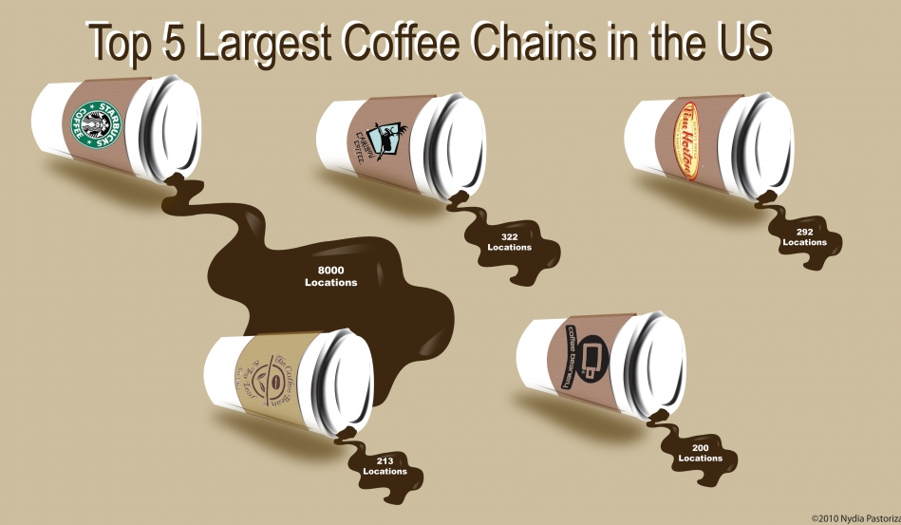

Teacher says but doesn’t show this on the overhead:
Starbucks is the largest coffee chain in the US with 8000 locations
Followed by Carribean coffee with 322 location
Tim Hortons is a close third with 292 locations
Followed by The Coffee Bean Company with 213 locations
Finally, the Coffee brewery with 200 locations

Appendix C
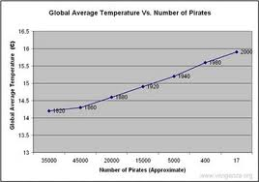
Name:_______________________________
- What was your initial reaction to the graph?
________________________________________________________________________________________________________________________________________________________________________________________________________________________________________________

- Do you think the information is true? Explain why or why not.
________________________________________________________________________________________________________________________________________________________________________________________________________________________________________________

- Do you think the information provided correlates relevantly? Explain why or why not.
________________________________________________________________________________________________________________________________________________________________________________________________________________________________________________

Appendix D
Possible Infographic Topics
You and your partner will choose a topic that interests both of you to represent in an infographic.
You may choose a different topic but will need to run it by me before you start to make it.
- School sports team statistics
- Most popular music genres or artists
- Top 10 most popular paintings, sculptures, museums, or artists
- Statistics on cultural or contemporary dance styles
- Statistics on hours per day of TV watched by Canadians
- Most popular video games
- Statistics on the most consumed food, condiment, or spice
- Statistics on country size, country populations, popular tourist destinations
- Statistics on the environment, animals, or global warming
- Most popular comics or manga
- The most purchased cosmetics or most expensive cosmetics
- Statistics on animal attacks
- Statistics on plane crashes
- Statistics on awards won by a famous movie or TV star
- Statistics on best cars, motorcycles, or skateboarders
These are just a few ideas and you are more than welcome to come up with something else.

Appendix E
What do Colours mean to you?
Name:_________________________
Write the name of the colour paper I hold up in the colour column
Think of and write what that colour represents for you. This can be a mood, feeling, place, thing or anything else you immediately think of.
Colour | Meaning
1)
2)
3)
4)
5)
6)
7)
8)
9)
10)
11)

Appendix F
Various Infographics – Check Data accuracy activity

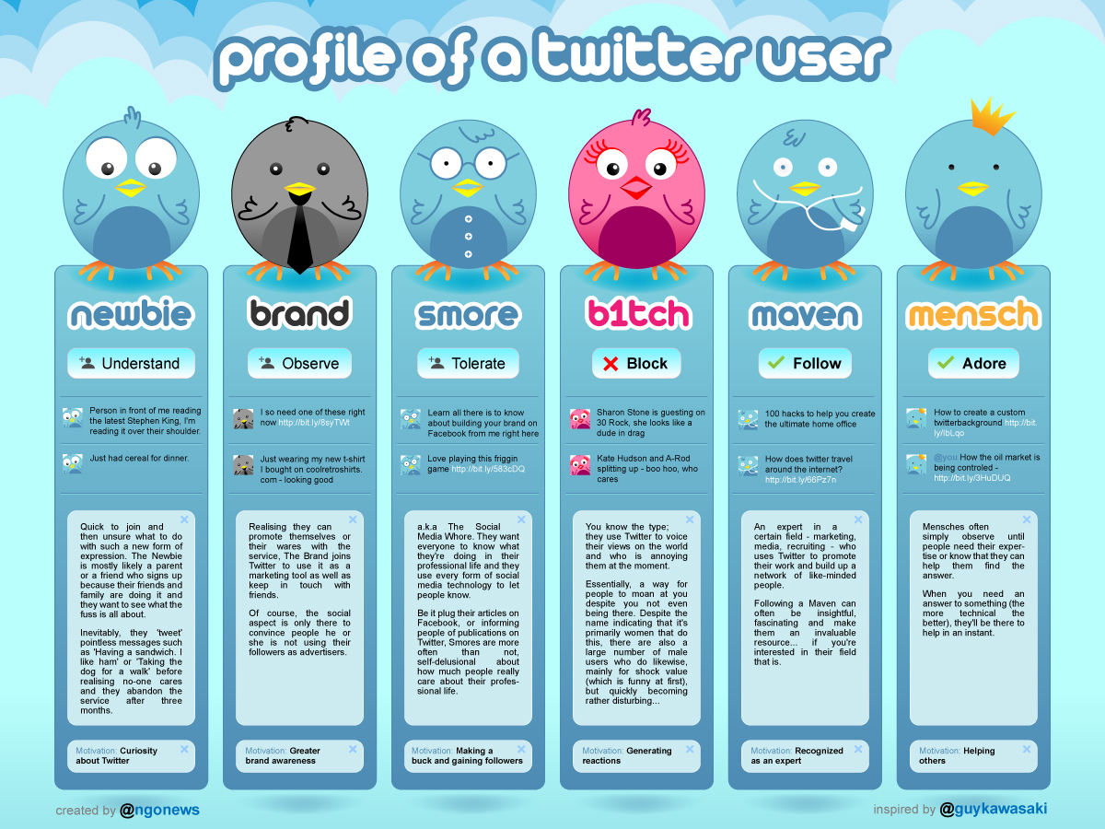

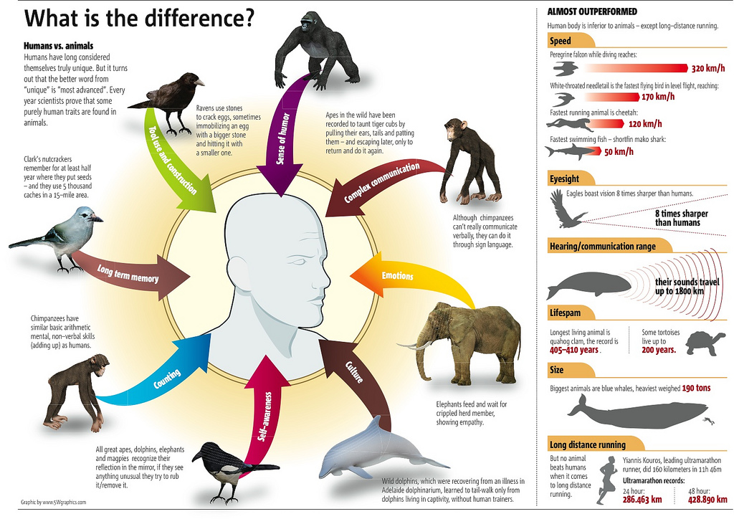

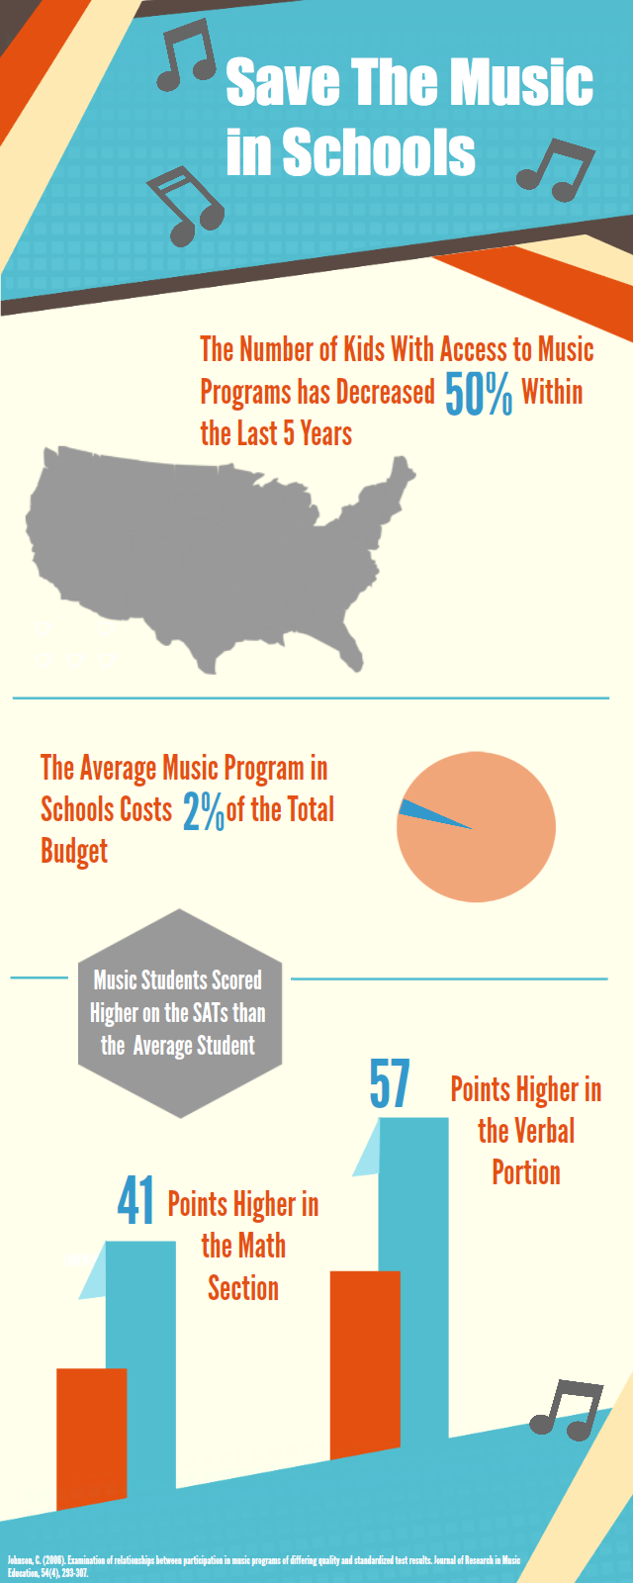
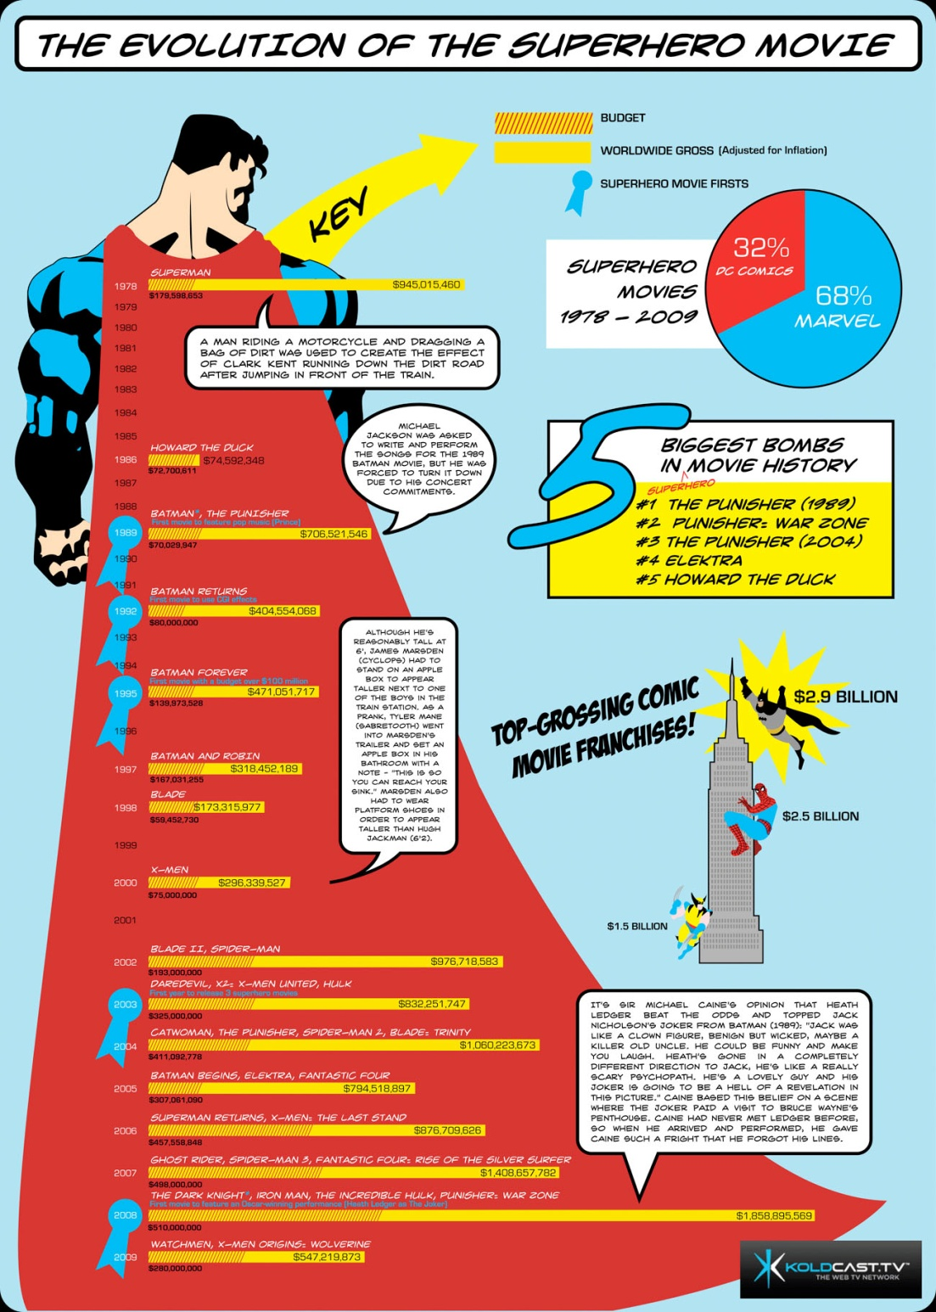

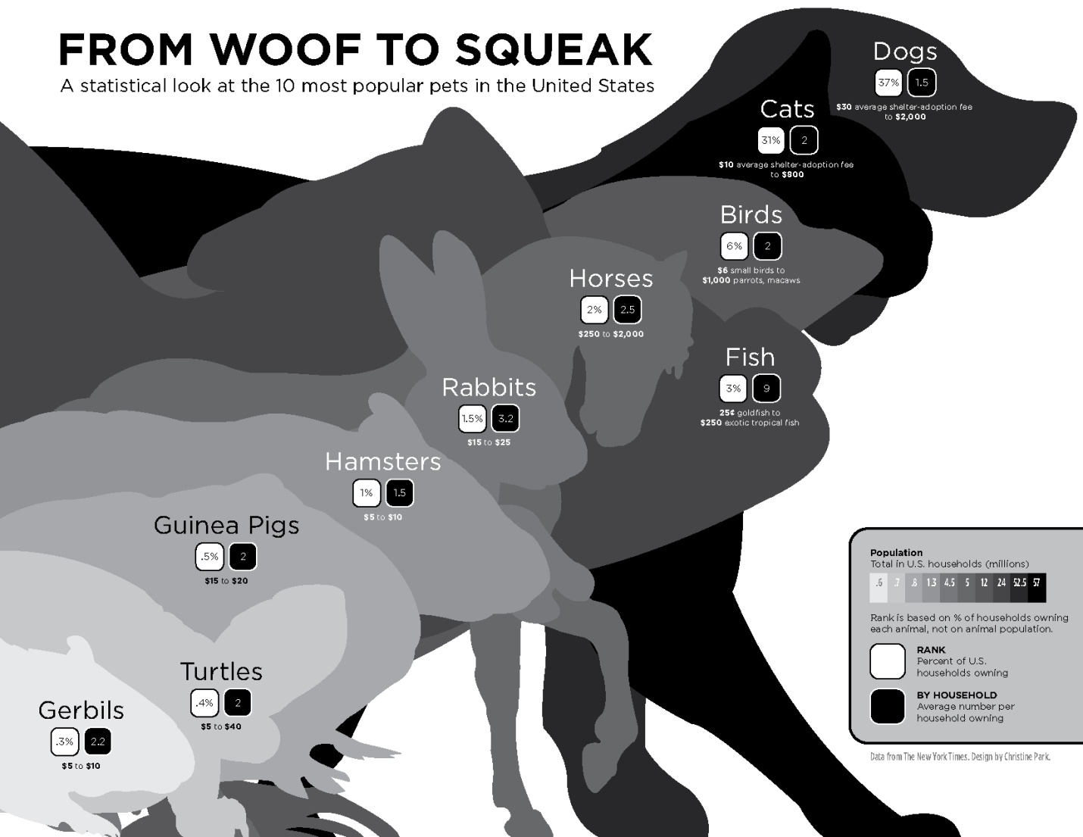

Appendix G
Data Research
Name:___________________________ Name:___________________________
- Do you think the information presented in the infographic is accurate?
__________________________________________________________________
- How did you discover its accuracy? What websites did you visit? Explain in detail.
________________________________________________________________________________________________________________________________________________________________________________________________________________________________________________________________________________________________________________________________________________________________________________________________________________________________________________________________________________________________
- What is the purpose for the infographic? To sell something, to give information, for entertainment. Is there bias in the information? Explain in detail.
________________________________________________________________________________________________________________________________________________________________________________________________________________________________________________________________________________________________________________________________________________________________________________________________________________

Appendix H
Explaining the accuracy of your Data
Name:___________________________ Name:___________________________
- Where did you find your data? (you can write web addresses)
________________________________________________________________________________________________________________________________________________________________________________________________________________________________________________

- How did you double check for accuracy?
________________________________________________________________________________________________________________________________________________________________________________________________________________________________________________

Student Exemplar

Name:_Martha Beardsworth
- What was your initial reaction to the graph?
Initially I thought this graph was quite funny but unnecessary as the two pieces of information seem unrelated.

- Do you think the information is true? Explain why or why not.
Yes, I do think the information is true. The Global average temperature went up over the years and the number of pirates decreased but I don’ think the number of pirates is responsible for the global average temperature increase.

- Do you think the information provided correlates relevantly? Explain why or why not.
No, I think there are other more reasonable reasons for the global average temperature going up like an increase in the number of cars and factories.

What do Colours mean to you?
Name:_Martha Beardsworth
Write the name of the colour paper I hold up in the colour column
Think of and write what that colour represents for you. This can be a mood, feeling, place, thing or anything else you immediately think of.
Colour | Meaning
- Red | Anger
- Black | Lonely
- White | Pure
- Grey | Rainy
- Blue | Sadness
- Green | Environmentally friendly
- Pink | Baby girls
- Orange | Halloween
- Purple | Excitement
- Yellow | Happiness
- Brown | Dirty

Data Research
Name:_Martha Beardsworth Name:___________________________
- Do you think the information presented in the infographic is accurate?
I originally questioned the first statistic of 50% of kids since 5 years ago having access to music programs in schools. Don’t all schools have music?
- How did you discover its accuracy? What websites did you visit? Explain in detail.
When I searched the information at the bottom of the infographic, it brought me to a scholarly journal published by the Journal of research in music education. I asked the teacher what that was and she told me it was a peer reviewed article which proves its accuracy.
- What is the purpose for the infographic? To sell something, to give information, for entertainment. Is there bias in the information? Explain in detail.
The purpose of the infographic is to give information. There might be bias in the data as it was prepared for a journal on music education to bring awareness to the importance of music education on other subjects like math and reading.

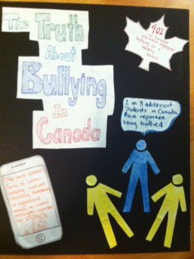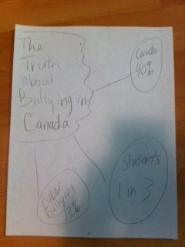

Infographic – The Truth about Bullying Infographic Skeleton

Explaining the accuracy of your Data
Name:_Martha Beardsworth Name:___________________________
- Where did you find your data? (you can write web addresses)
I found the information on Stats Canada - http://www.cihr-irsc.gc.ca/e/45838.html

- How did you double check for accuracy?
I double checked by looking at the statistics that Stats Canada referenced.
Molcho M., Craig W., Due P., Pickett W., Harel-fisch Y., Overpeck, M., and HBSC Bullying Writing Group. Cross-national time trends in bullying behaviour 1994-2006: findings from Europe and North America. International Journal of Public Health. 2009, 54 (S2): 225-234
http://www.bullyfreealberta.ca/homophobic_bullying.htm
Lee R.T., and Brotheridge C.M. “When prey turns predatory: Workplace bullying as predictor of counteragression / bullying, coping, and well-being”. European Journal of Work and Organizational Psychology. 2006, 00 (0): 1-26

